**Updates**

* Step 1, increasing the data, has been achieved and also the focus of training is now on only 2 classes, Sleep and Nirodha, as opposed to 4 classes
* The accuracy results for various time window sizes (in ms) are as follows :

| **Time Window Size (in ms)** | **Epochs of Training** | **Sleep Accuracy** | **Nirodha Accuracy** | **Overall Accuracy** |
| --- | --- | --- | --- | --- |
| 1000 | 50 | 72.09% | 74.80% | 73.43% |
| 900 | 50 | 65.97% | 74.21% | 70.05% |
| 800 | 50 | 76.16% | 75.39% | 75.78% |
| 700 | 50 | 65.26% | 78.86% | 72.13% |
| 600 | 50 | 78.03% | 73.92% | 75.97% |
| 500 | 50 | 67.187% | 80.07% | 73.63% |
| 400 | 50 | 67.39% | 74.84% | 71.09% |
| 300 | 50 | 78.66% | 69.73% | 74.21% |
| 200 | 50 | 75.03% | 69.70% | 72.42% |
| 100 | 50 | 75.04% | 72.08% | 73.56% |

| Mean Overall Accuracy Across all the Time Window Sizes | 73.227% |
| --- | --- |
| Standard Deviation | 1.8808 |

**Loss Curves**

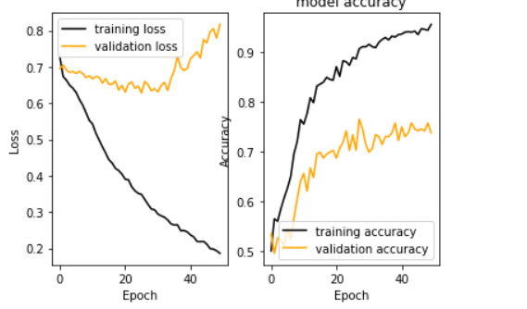

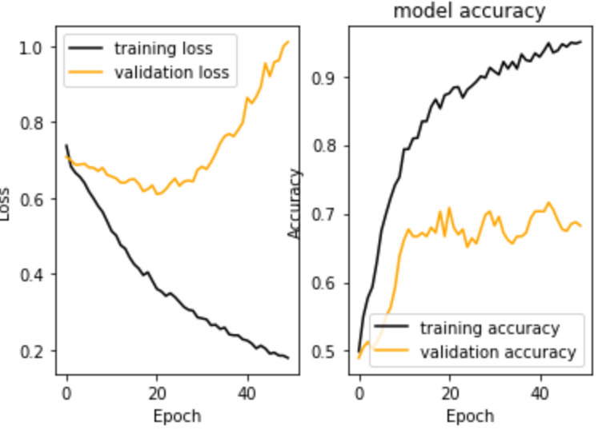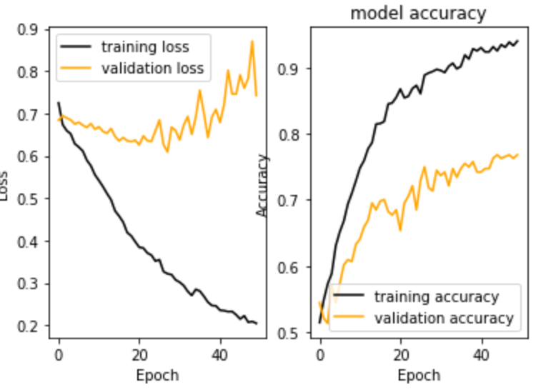

1000ms 900ms 800ms

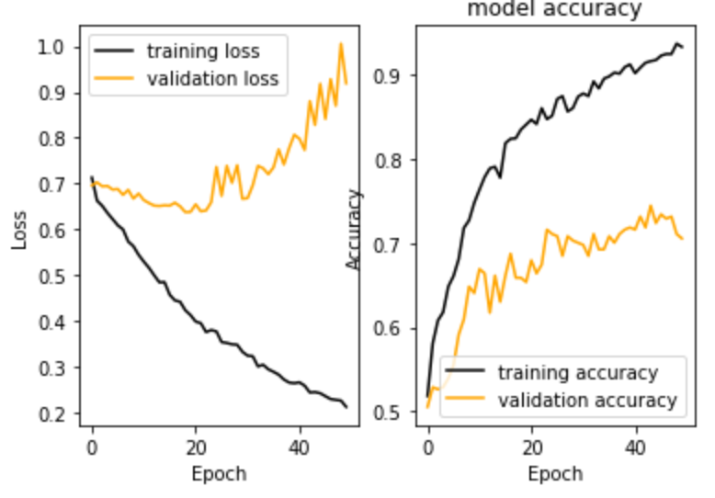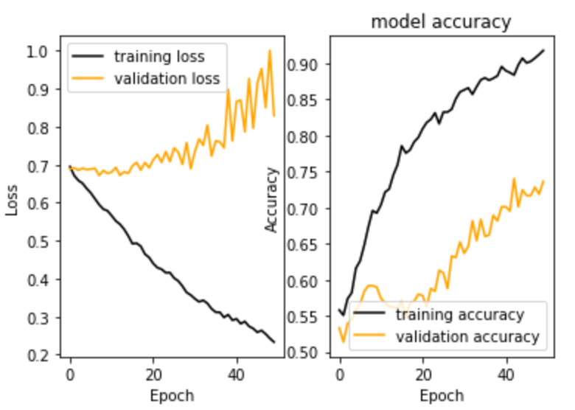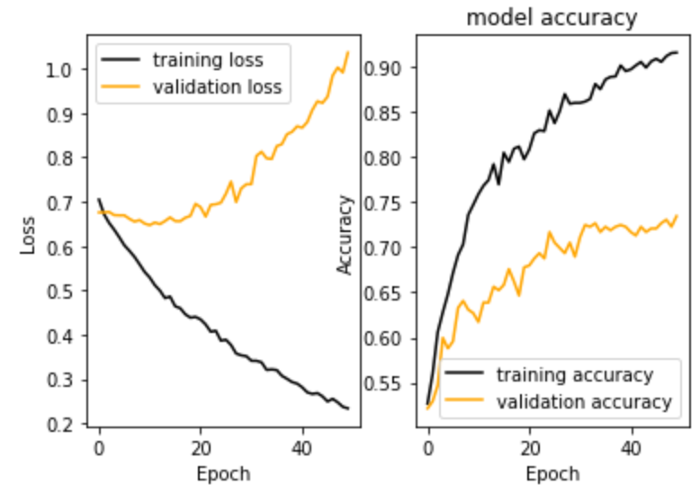

700ms 600ms 500ms

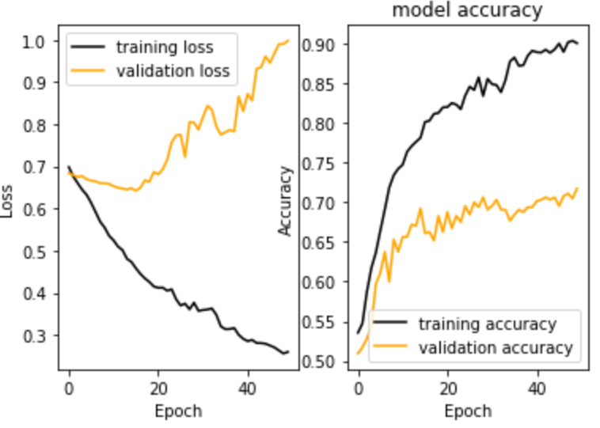 -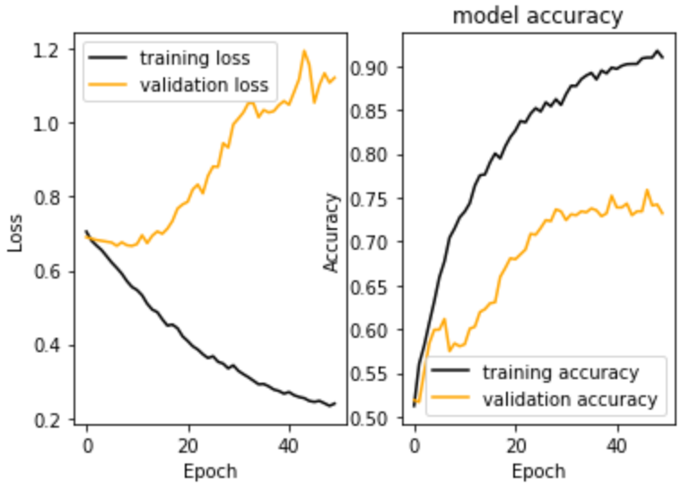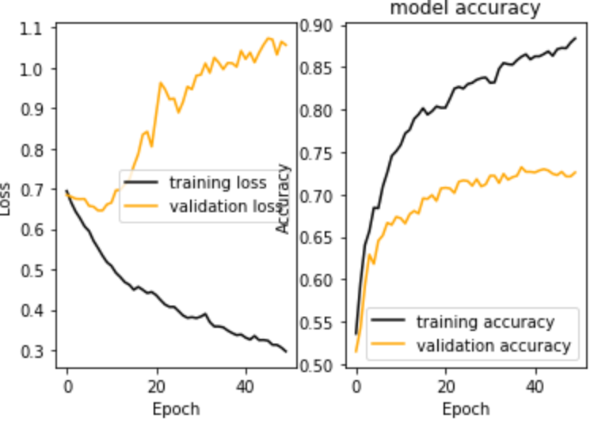

400ms 300ms 200ms

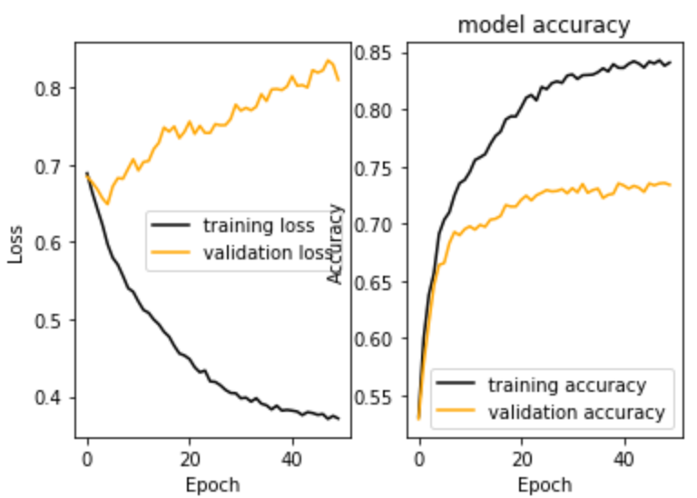

100ms

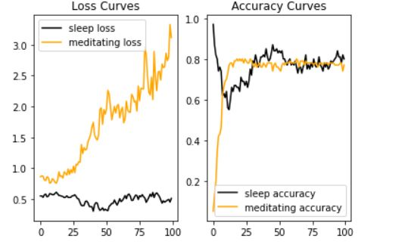

*Img : class-wise loss curves*

Note :

After analyzing loss curves of models trained on different time-window sizes of dataset samples, a strange phenomenon was observed where the validation/test loss of the model increased, but the accuracy of validation/test samples also increased. A breakdown of the class-wise components of these loss curves provided an explanation for this unusual trend. The issue was that during training, one class (sleep class) was being learned well as the number of epochs increased, while the other class (nirodha class) was not being learned as effectively. As a result, the model's ability to correctly predict the learnable class contributed to the increasing validation/test accuracy, while the unlearnable class's loss increasingly added to the overall validation/test loss with each new epoch. However, after a certain number of epochs, the learnable class's loss began to stabilize, while the unlearnable class's loss continued to increase rapidly, ultimately causing the final validation/test accuracy to remain constant. It is therefore important to stop training the model at a point where it fails to learn patterns in both, not just one class, learnable and unlearnable classes, which was found to be around epoch 50. Thus, continuing training for longer epochs is not advisable, nor is stopping it as soon as validation loss begins to rise.

**Confusion Matrices**

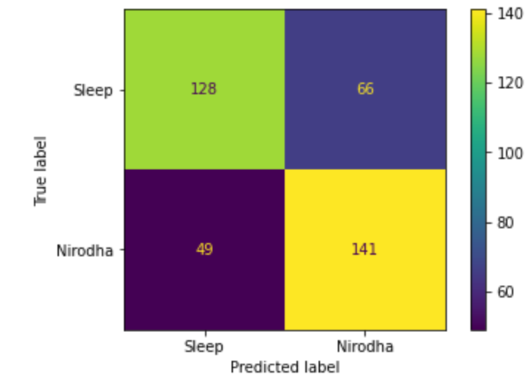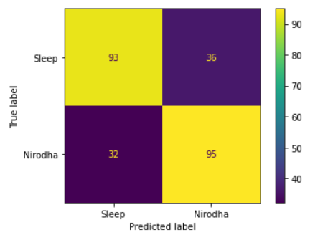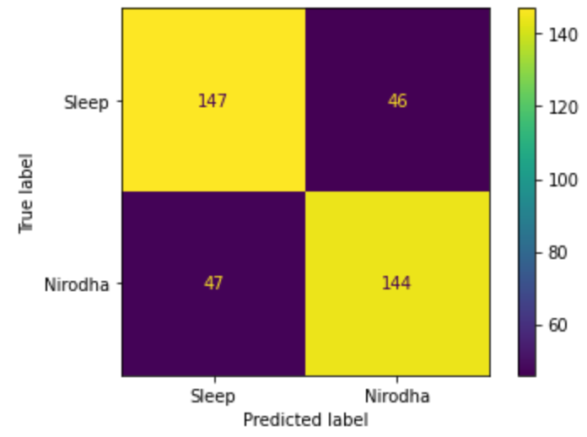

1000ms 900ms 800ms

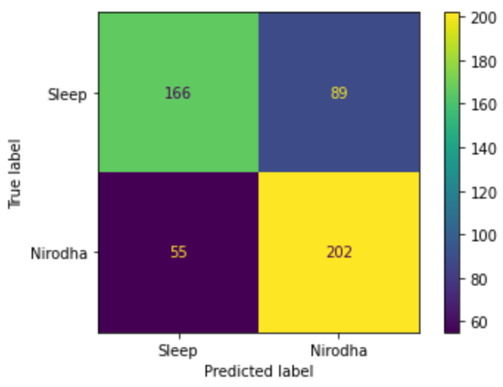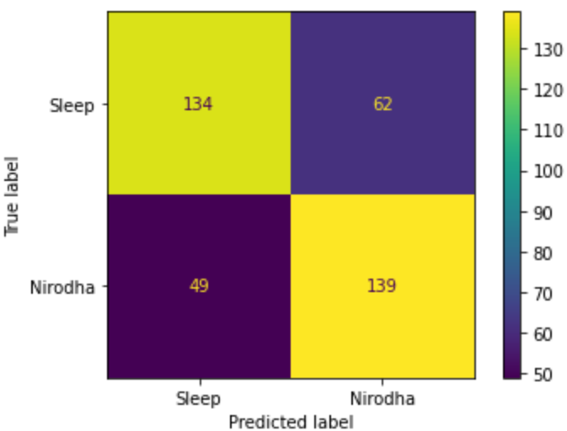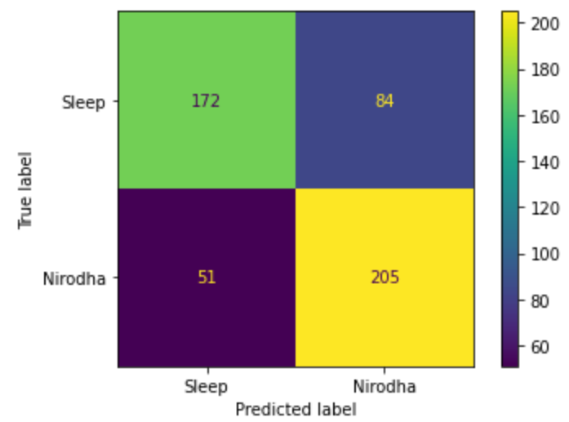

700ms 600ms 500ms

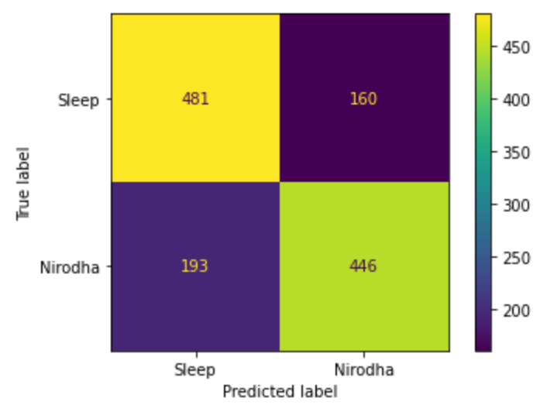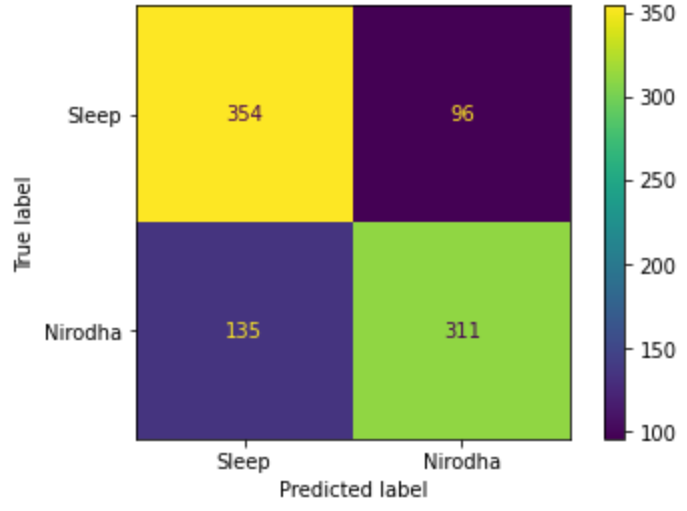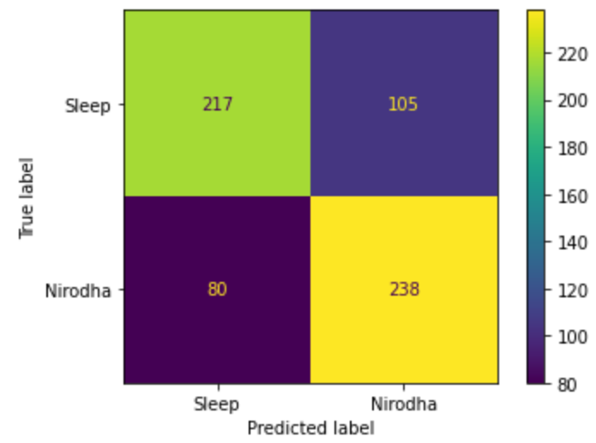

400ms 300ms 200ms

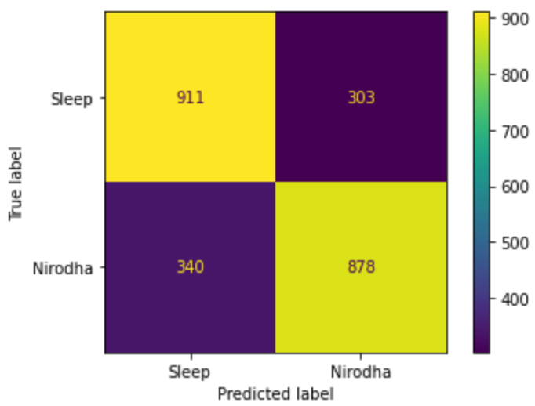

100ms ->

**Steps to be Done**

* Look into accommodating non-EEG signals for better model predictions
* Deepen the preprocessing steps
* Tweak the Frequency Domain